[How to set up SQuirreL](https://teraworks.td.teradata.com/display/NEXTGEN/How+to+set+up+SQuirreL)

SQuirrel is a SQL client used for connection to different databases.

**1.** **SQuirrell installation:**

The first step to getting it configured is to download it from the <http://squirrel-sql.sourceforge.net/> . Click on squirrel-sql-3.7 to download it. Download the latest version.   Once it downloads, open it and follow the instructions, taking all defaults to install it.

Bring up SQuirrell. If it does not come up, you might need Java SDK. You can download it from <http://www.oracle.com/technetwork/java/javase/downloads/jdk8-downloads-2133151.html>

**Connecting to Teradata**

**2.** **Get Teradata JDBC Driver:**

Use the JDBC driver .jar files provided at the beginning of the event.

Or obtain JDBC driver for Teradata database at  <http://downloads.teradata.com/download/connectivity/jdbc-driver> .

Download the version (i.e. the latest 15.10) of your choice either the .zip or .tar file.  For example TeraJDBC__indep_indep.15.10.00.09.zip

Unzip or untar the (terajdbc4.jar, tdgssconfig.jar) into local directory.  (i.e. C:\terajdbc)

**3.** **Creating new driver steps:**

On the Drivers tab on the left, click the blue plus sign to create a new driver.

Fill in the following information on the Add Driver screen:

Name: Teradata Driver

Example URL: jdbc:teradata://153.64.73.17/TMODE=ANSI,CHARSET=UTF8

Website URL: www.teradata.com

Class Name: com.teradata.jdbc.TeraDriver

Click on the "Extra Class Path" tab to add the two terajdbc4.jar and tdgssconfig.jar from the download and unzip steps.

Click "Add" and navigate to the location of the jdbc jar files (i.e. C:\terajdbc\terajdbc4.jar, C:\terajdbc\tdgssconfig.jar)

When done, click "OK" to exit the "Add Driver" screen.

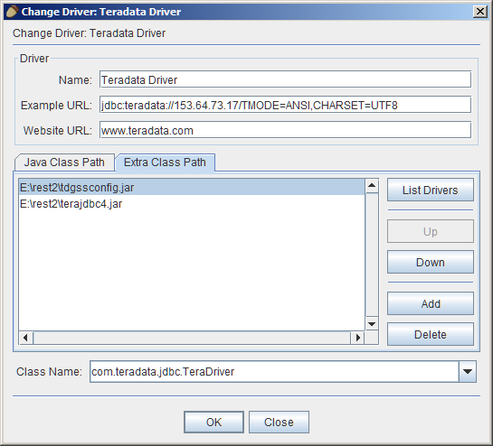

**4. Creating new alias steps:**

On the Aliases tab on the left, click the blue plus sign to create a new alias.

Fill in the following information on the Add Alias screen:

Name: DatabaseServer

Driver: Teradata Driver (select it from the menu)

URL: jdbc:teradata://153.64.73.17/TMODE=ANSI,CHARSET=UTF8

Username: -Your Assigned Database User Name

Password: -Your Assigned Database User Password

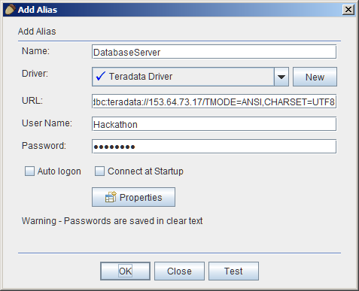

Click "Test" button to test.   Click Connect to test connection.  If "Connection successful" prompt appears, click OK, the OK to exit "Add Alias" screen.

Now to can select your alias and click the connect button on the "Aliases" windows to connect to your teradata database and start working...